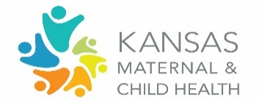
Title V Block Grant Review of Accomplishments and Data Trends
Domain Group: Women and Maternal

Considering the information provided, answer the following questions:

Review the data for your population domain in the NOM/NPM/SPM Table. What trends stand out to you?
NOM’s: 1-9.4; 10-11, 23-24 NPM’s: 1-2 SPM’s: 1
What contributing factors may be associated with the trend you are seeing? Share any specific examples or stories related to contributing factors.
What emerging needs might impact this trend in the next couple of years? How might we address those?
Reflect on the upcoming activities from the State Plan in the Block Grant for your population domain, as presented today.
Upcoming Activities |  | What opportunities exist to elevate or further advance existing efforts? | What non-KDHE/Title V initiatives exist that align with these particular activities?
- Well-Woman Toolkits for Providers and Communities
  - Continued distribution, promotion and training
  - Supporting materials (soon available in Spanish)

- Integrated Prescreening Tool
  - Substance use, tobacco use, mental health, social determinants of health, intimate partner violence
  - Incorporate into all preventive medical visits for women

- Kansas Connecting Communities
  - Continue to build and expand on the screening and treatment of PMADs and substance use during and after pregnancy.

- Medicaid Policy Changes
  - Expand pregnancy coverage through 12 months postpartum
  - Screening for PMADs as a covered service
Looking at the plan overview for this domain, what is your commitment as a council member and the organization you represent to advance this plan? Share here: https://forms.gle/AJrBkeEHNfbjw25r7

